Contact Details
*Name:
*Address:
*Phone Number:
*Email:

Display Information
*Please select a category for your nomination (one only):
☐Best Display ☐Best Sustainable Display ☐Display Map Only
*Please tell us a little bit about your display:
If you are entering the Best Sustainable Display category, please indicate if your display features:
☐Solar lights ☐LED lights
☐Timing systems ☐Decorations made from recycled items
☐Handmade decorations

Confirm Nomination
*Please let us know how many years you have entered the Festive Lights and Decorations Competition:
☐1 year ☐2 years ☐3 years ☐4-6 years ☐7-9 years ☐10+ years
*I confirm I have read and agree to the Terms and Conditions of Town of Port Hedland Festive Lights and Decorations Competition 2019:
Signature:
Date:
Please return completed forms to agroch@porthedland.wa.gov.au, the Civic Centre - McGregor Street or South Hedland Library – Leake Street, South Hedland. Nominations close Wednesday 4 December 2019 at 5.00pm AWST.
*Required question

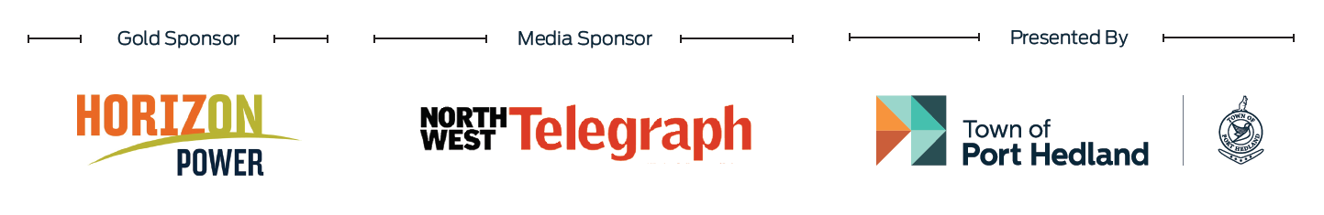

Terms and Conditions of Town of Port Hedland Festive Lights and Decorations Competition 2019
1 The Promoter is the Town of Port Hedland (ABN 19 220 085 226) of Civic Centre, 13 McGregor Street, Port Hedland (‘Civic Centre’). Contact (08) 9158 9300.
2 By entering this competition, the entrant accepts these terms and conditions.
3 Entry to the competition is free.
4 Entry to the competition commences on 6 November 2019 and closes on 4 December 2019 at 5.00pm AWST. Entry forms are available on the Town of Port Hedland website, at the South Hedland Library and Civic Centre. Completed hard copy entry forms can be submitted at the South Hedland Library and Civic Centre.
5 To be eligible, entrants:
(a) must complete and return a nomination form prior to the closing date and time as specified above
(b) must decorate their property with festive lights and/or decorations that are visible from the street front;
(c) must select one of the following categories: Best Display or Best Sustainable Display
(d) cannot be an employee of the Town of Port Hedland, or a member of that employee’s immediate family; and
(d) cannot be an employee of any agencies associated with this competition, or a member of that employee’s immediate family.
6 All eligible entries for each category are also eligible for People’s Choice.
7 Entrants agree to have their address included on the Festive Lights and Decorations Competition Map to be distributed to the Port Hedland community, and name and photograph of their decorated property published in association with this contest.
8 Prize winners:
(a) Best Display prize winners: will be selected by a judging panel scoring the entrant on a scale of 1 to 5 in the following three areas: theming, creativity, and capturing festive cheer. The entrant with the highest total score is the Best Display prize winner. The entrant with the second highest total score is the Runner Up Best Display prize winner.
(b) Best Sustainable Display prize winner: will be selected by a judging panel scoring the entrant on a scale of 1 to 5 in the following four

areas: theming, creativity, capturing festive cheer, and sustainable features. The entrant with the highest total score is the prize winner.
(c) Judging will occur between 6.00pm and 11.00pm AWST on 10 December 2019.
(d) The judging panel comprises of one Horizon Power representative and one Town of Port Hedland representative.
(e) People’s Choice prize winner: will be selected by the most votes received by the public. Voting for People’s Choice commences 6 December 2019 and closes on 20 December 2019 at 5.00pm AWST. Voting is conducted via the Town of Port Hedland website or in person at the South Hedland Library or Civic Centre. Voters may only vote once.
9 Prizes:
(a) consists of $850 cash for the Best Display prize winner;
(b) consists of $700 cash for the Runner Up Best Display prize winner;
(c) consists of $550 cash for the Best Sustainable Display prize winner;
(d) consists of $350 cash for the People’s Choice prize winner;
(e) is not redeemable for cash.
(f) the prize winners for Best Display and Best Sustainable Display will be published on the Town’s website by 5.00pm AWST on 13 December 2019. The People’s Choice winner will be published on the Town’s website on 21 December 2019. The Town will contact prize winners on the contact details provided in the entry form.
(g) if the Town cannot locate a prize winner and/or the prize winner does not collect their prize within 14 days (or as otherwise agreed) of selection of the winner, second place in the respective category will receive the prize.
10 The Town’s decision regarding the category winners is final.
11 The Town is not liable for any loss or damage whatsoever, or for any personal injury suffered or sustained, as a result of entering this competition or using any of the prizes.
12 Personal information provided for the purpose of entering this competition will be collected, used and disclosed in accordance with the relevant privacy laws.

Immediate family means mother, father, daughter, son, brother, sister, husband, wife or defacto husband or wife living at the same residential address as the employee.
As above.

