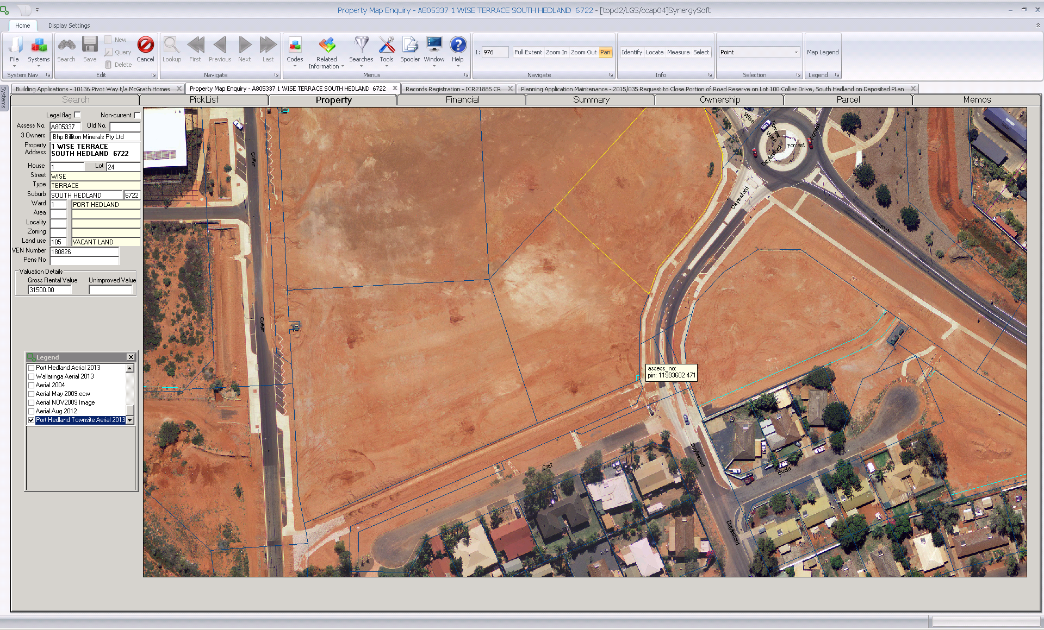

Portion of road reserve to be closed – 18m².